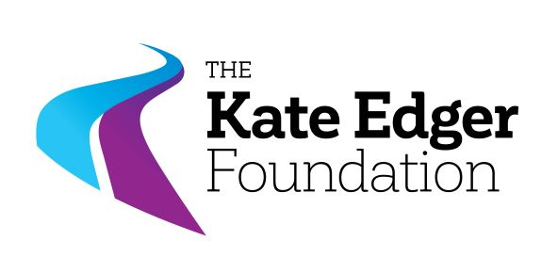

**Māori & Pasifika Midwifery Award**

**PURPOSE**

This award is to support a Māori or Pasifika student enrolled full-time in the third year or above of the Bachelor of Health Sciences - Midwifery programme at Auckland University of Technology (AUT).

**Closing date: 10 February 2025**

**REGULATIONS**

1. One Award of $2,500 will be available for offer annually.
2. Applicants for the Award must be:
   1. New Zealand Citizens or **Permanent** Residents;
   2. Of Māori or Pasifika descent;
   3. Enrolled full-time* in the third or fourth year of either the accelerated or standard Bachelor of Health Sciences – Midwifery programme at AUT.
3. In making these awards, the selection committee shall give consideration to:
   1. the applicant’s commitment to a midwifery career in Māori and/or Pasifika communities ;
   2. the applicant’s personal statement (of no more than 500 words) explaining why they have chosen a career in midwifery;
   3. the applicant’s academic record; (for the purpose of this award, academic merit will be assessed from the GPA or GPE obtained over the applicant’s most recent two years of graded study in the Midwifery programme at AUT);
   4. the applicant’s referee’s report;
   5. the applicant’s need for financial assistance;
   6. any special circumstances, e.g. family responsibilities, personal disability, considered relevant.
   7. Applicants’ involvement in extra-curricular/co-curricular activities, leadership/tuakana roles will be of interest to the committee.
4. Each application for these awards must include the name of one referee from whom a confidential reference may be sought.
5. These awards may be held concurrently with another award if the regulations for that award so permit.
6. The KEECT Māori & Pasifika Midwifery Award shall be paid in one instalment directly to the recipient at the beginning of the academic year on receipt of proof of enrolment in the Midwifery programme at AUT.
7. The successful applicant is required to complete her year of study and make a brief report at the end of this study. Failure to complete two full consecutive semesters may require refund of the full value of the award.

*This scholarship is intended for students studying full-time towards a qualification. The Trustees understand that personal circumstances such as health conditions or impairments can limit a person’s ability to study full-time. Applications from students studying part-time due to disability will be therefore considered, but the applicant must include documentation supporting their reason for studying part-time. Examples of supporting documents include a letter of support from a disability service provider, the Students with Disabilities office, or your general practitioner. Students studying part-time due to disability who are successful in their application will be paid a pro-rata amount. For the purposes of this Award, a disability refers to both visible and invisible impairments including: blind and low vision, deaf and hearing impaired, head injury, ongoing medical conditions, diagnosed mental health conditions, physical/mobility impairments, speech impairments, Autism Spectrum Disorder, specific learning disabilities (e.g. dyslexia, dyspraxia, dyscalculia).

**Closing date: 10 February 2025.**