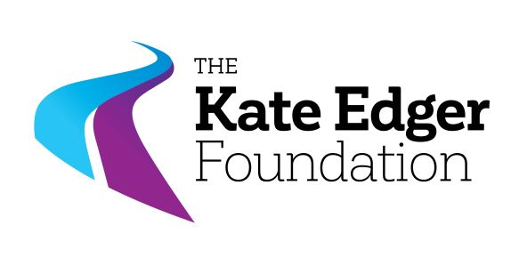

Scholarship, in honour of the Polish children  
and caregivers of Pahīatua

**Closing date: 18 October 2025**

**PURPOSE**

This scholarship is in honour of the 733 Polish children and their mainly female caregivers who, initially deported from Eastern Poland to Siberia during World War II, were invited by the New Zealand government to stay in Pahīatua in 1944. Many of these children, most of them orphans and without their families, remained in New Zealand when they could not return to Poland, building new lives in their ‘paradise’.

Nina Tomaszyk wanted to acknowledge this Polish group of Pahīatua and also the people of NZ for their hospitality and generosity. She is President of the Auckland Polish Association; granddaughter of one of the caregivers, Krystyna Skwarko (who wrote The Invited) and daughter of Krystyna Tomaszyk (who wrote the books Essence and Polish children in Isfahan 1042 to 1944, which are available in Polish and English); also General Manager of Kate Edger Foundation. Nina saw the importance of education to the Polish community, and to all communities through her work at Kate Edger Foundation, so thought a scholarship was one of the ways to commemorate the arrival of the group in 1944.

The scholarship recognises women committed to community engagement or cultural preservation. It is intended to assist women students currently in Year 12 or 13 at a secondary school in Auckland or Northland, who will be enrolling full-time for a degree or diploma at an approved tertiary institute in the Auckland or Northland region in 2026. The Award is available to contribute towards the payment of fees or living costs associated with tertiary study.

The Kate Edger Foundation encourages, advances, and promotes education, empowering women. It is neutral and independent of all institutes and offers unbiased and professional Selection Panels, under the wing of the Awards Committee. The board of the Kate Edger Foundation consists of six professionals. The scholarships provide financial assistance as well as an acknowledgement of reaching one’s goals of their educational pathway.

**Donations towards this scholarship are much appreciated (100% of the donation will go to the recipient of the scholarship).** Tax receipt will be provided.

Enquiries to:   
Nina Tomaszyk, General Manager [nina.tomaszyk@KateEdgerFoundation.org.nz](mailto:nina.tomaszyk@KateEdgerFoundation.org.nz), or

Awards Coordinator [awards@kateedgerfoundation.org.nz](mailto:awards@kateedgerfoundation.org.nz)

**Closing date: 18 October 2025**

**REGULATIONS**

1. An Award of $2,000 to support full-time study (120 points per annum).
2. The applicant must be:
   1. a woman.
   2. a New Zealand Citizen or **Permanent** Resident.
   3. an enrolled student at a secondary school in Auckland or Northland.
   4. intending to enrol full-time in a degree course at an NZQA-approved tertiary institute in Auckland or Northland.
3. In making this award, the selection committee shall consider:
   1. applicant’s need for financial assistance;
   2. applicant’s academic record as evidence of ability to complete the course;
   3. applicant's commitment to community engagement and/or cultural preservation;
   4. referee’s report;
   5. applicant’s aspirations for the future;
   6. any special circumstances considered relevant, e.g. family responsibilities
4. This award may be held concurrently with an award of any value if the regulations for that award so permit.
5. The Award shall be paid on the presentation of proof of enrolment as a full-time student at a NZQA approved institute in New Zealand.
6. The successful applicant is required to complete a brief report at the end of their first year of study.
7. Each applicant for these awards must submit their application **on the current prescribed application form**, together with:
   1. certified copy or statutory declaration of academic record (from the last two years of secondary study);
   2. certified copy of evidence of status as a New Zealand Citizen or Permanent Resident (not Driver Licence);
   3. certified copy of evidence of status as an enrolled student at an Auckland or Northland secondary school (e.g. copy of student ID).
   4. certified statement on the prescribed form.

**“Certified copy” means a copy of the original, certified as true by an appropriate authority (for example, Registrar, Head of Department or Study Supervisor, or Justice of the Peace).   
  
A “Statutory Declaration” must be made before a Justice of the Peace or Solicitor on the appropriate form.**